**Associations between Per- and Polyfluoroalkyl Substances and Incident Natural Menopause**

*Ning Ding1, Siobán D. Harlow1, John F. Randolph Jr.2, Antonia M. Calafat3,*

*Bhramar Mukherjee4, Stuart Batterman,5,6, Ellen B. Gold7, Sung Kyun Park1,5*

1Department of Epidemiology, School of Public Health, University of Michigan, Ann Arbor, MI, United States

2Department of Obstetrics and Gynecology, School of Medicine, University of Michigan, Ann Arbor, MI, United States

3Division of Laboratory Sciences, National Center for Environmental Health, Centers for Disease Control and Prevention, Atlanta, GA, USA

4Department of Biostatistics, School of Public Health, University of Michigan, Ann Arbor, MI, United States

5Department of Environmental Health Sciences, School of Public Health, University of Michigan, Ann Arbor, MI, United States

6Department of Civil and Environmental Engineering, College of Engineering, University of Michigan, Ann Arbor, MI, United States

7Department of Public Health Sciences, University of California, Davis, School of Medicine, Davis, CA, United States

**Corresponding author**: Sung Kyun Park, Department of Epidemiology, University of Michigan, M5541 SPH II, 1415 Washington Heights, Ann Arbor, MI 48109-2029. Phone: (734) 936-1719. Fax: (734)936-2084. E-mail: [sungkyun@umich.edu](mailto:sungkyun@umich.edu).

**Disclosure:** The authors declare no competing financial interest.

**TABLES AND FIGURES**

**Table S1** Baseline participant characteristics overall and by K-means clusters.

**Table S2** Covariates included in the imputation model for FMP age.

**Table S3** Median (inter-quartile range, IQR) serum concentrations of n-PFOS, Sm-PFOS, PFHxS, PFDoA, PFUnDA, PFDA, PFNA, n-PFOA, and Sb-PFOA by racial/ethnic groups at the MPS baseline (1999-2000).

**Table S4** Hazard ratio (HR) (95% confidence interval, 95% CI) of n-PFOS, Sm-PFOS, n-PFOA, PFNA, and PFHxS serum concentrations on incidence of natural menopause with surgical menopause excluded instead of censored (n=1051).

**Table S5** Hazard ratio (HR) (95% confidence interval, 95% CI) of n-PFOS, Sm-PFOS, n-PFOA, PFNA, and PFHxS serum concentrations on incidence of natural menopause after excluding women who reached menopause in 6 months instead of censored (n=1091).

**Table S6** Hazard ratios (HR) (95% confidence intervals, 95% CI) for incident natural menopause with tertile changes and per doubling increase in serum concentrations of n-PFOS, Sm-PFOS, n-PFOA, PFNA, and PFHxS in 720 women who had never smoked before.

**Table S7** Pooled HR (95% CI) for incident natural menopause with tertile changes and per doubling increase in serum concentrations of n-PFOS, Sm-PFOS, n-PFOA, PFNA, and PFHxS in 720 women who had never smoked before with 10 imputations.

**Table S8** Adjusted HR (95% CI) of incident natural menopause with per doubling increase in serum concentrations of n-PFOS, Sm-PFOS, n-PFOA, PFNA, and PFHxS in 720 women who had never smoked before.

**Table S9** Hazard ratio (HR) (95% confidence interval, 95% CI) of natural menopause incidence with by PFAS clusters.

**Figure S1** Designs of the Study of Women’s Health Across the Nation Multi-Pollutant Study (SWAN MPS).

**Figure S2** Spearman correlation matrix of PFAS biomarkers in SWAN 1999-2000.

**Figure S3** Adjusted survival curves of natural menopause by tertiles of n-PFOS serum concentrations.

**Figure S4** Adjusted survival curves of natural menopause by tertiles of Sm-PFOS serum concentrations.

**Figure S5** Adjusted survival curves of natural menopause by tertiles of n-PFOA serum concentrations.

**Figure S6** Adjusted survival curves of natural menopause by tertiles of PFNA serum concentrations.

**Figure S7** Adjusted survival curves of natural menopause by tertiles of PFHxS serum concentrations.

**Figure S8** Adjusted hazard ratio (HR) (95% confidence interval, 95% CI) of natural menopause incidence with per doubling increase in serum concentrations of n-PFOS, Sm-PFOS and PFHxS.

**Figure S9** Cluster means of the 5 standardized log-transformed serum PFAS concentrations using k-means clustering.

**Table S1** Baseline participant characteristics overall and by K-means clusters.

|  |  |  |  |  |  |  |
| --- | --- | --- | --- | --- | --- | --- |
| **Baseline characteristic** | **Total**  **(n=1120)** | **Low**  **(n=143)** | **Low-medium**  **(n=414)** | **Medium-high**  **(n=406)** | **High**  **(n=157)** | **P valuea** |
| Median (IQR)  or n (%) | Median (IQR)  or n (%) | Median (IQR)  or n (%) | Median (IQR)  or n (%) | Median (IQR)  or n (%) |
| Age, years | 48.9 (47.0-50.8) | 49.1 (47.0-50.7) | 49.2 (47.2-51.1) | 48.6 (46.9-50.4) | 48.4 (46.9-50.8) | 0.04 |
| Race/ethnicity |  |  |  |  |  | <.0001 |
| White | 577 (51.5%) | 60 (42.0%) | 199 (48.1%) | 226 (55.7%) | 92 (58.6%) |  |
| Black | 235 (21.0%) | 30 (21.0%) | 63 (15.2%) | 88 (21.7%) | 54 (34.4%) |  |
| Chinese | 142 (12.7%) | 36 (25.1%) | 73 (17.6%) | 33 (8.1%) | 0 (0.0%) |  |
| Japanese | 166 (14.8%) | 17 (11.9%) | 79 (19.1%) | 59 (14.5%) | 11 (7.0%) |  |
| Study site |  |  |  |  |  | <.0001 |
| Southeast MI | 202 (18.0%) | 17 (11.9%) | 67 (16.2%) | 70 (17.2%) | 48 (30.6%) |  |
| Boston, MA | 182 (16.3%) | 23 (16.1%) | 62 (14.9%) | 78 (19.2%) | 19 (12.1%) |  |
| Oakland, CA | 242 (21.6%) | 51 (35.7%) | 115 (27.8%) | 61 (15.0%) | 15 (9.6%) |  |
| Los Angeles, CA | 299 (26.7%) | 34 (23.8%) | 115 (27.8%) | 122 (30.1%) | 28 (17.8%) |  |
| Pittsburgh, PA | 195 (23.4%) | 18 (12.6%) | 55 (13.3%) | 75 (18.5%) | 47 (29.9%) |  |
| Educational attainment |  |  |  |  |  | 0.002 |
| ≤High school | 197 (17.7%) | 28 (19.6%) | 73 (17.7%) | 61 (15.1%) | 35 (22.4%) |  |
| Some college | 350 (31.4%) | 43 (30.0%) | 110 (26.8%) | 144 (35.6%) | 53 (34.0%) |  |
| College | 271 (24.3%) | 48 (33.6%) | 109 (26.5%) | 86 (21.3%) | 28 (18.0%) |  |
| Post-college | 296 (26.6%) | 24 (16.8%) | 119 (29.0%) | 113 (28.0%) | 40 (25.6%) |  |
| Parity |  |  |  |  |  | 0.02 |
| Nulliparous | 215 (19.2%) | 16 (11.2%) | 76 (18.4%) | 92 (22.7%) | 31 (19.8%) |  |
| Parous | 905 (80.8%) | 127 (88.8%) | 338 (81.6%) | 314 (77.3%) | 126 (80.2%) |  |
| Prior hormone use | 248 (22.1%) | 33 (23.1%) | 87 (21.0%) | 83 (20.4%) | 45 (28.7%) |  |
| Smoking status |  |  |  |  |  | 0.001 |
| Never smoker | 720 (64.4%) | 99 (69.7%) | 291 (70.3%) | 246 (60.7%) | 84 (53.5%) |  |
| Former smoker | 291 (26.0%) | 34 (23.9%) | 96 (23.2%) | 109 (26.9%) | 52 (33.1%) |  |
| Current smoker | 107 (9.6%) | 9 (6.3%) | 27 (6.5%) | 50 (12.4%) | 21 (13.4%) |  |
| Physical activity score | 7.9 (6.6-9.0) | 7.5 (6.3-8.8) | 7.9 (6.5-9.1) | 7.9 (6.8-9.0) | 7.7 (6.6-8.6) | 0.11 |
| Body mass index, kg/m2 | 26.1 (22.7-31.5) | 24.6 (22.4-30.2) | 25.6 (22.3-30.1) | 26.4 (22.7-31.8) | 29.4 (24.9-35.1) | <.0001 |

a The significance level was set at 0.05.

**Table S2** Covariates included in the imputation model for FMP age.

|  |
| --- |
| **Covariates related to timing of menopause** |
| Race/ethnicity |
| Study site |
| Frequency of vasomotor symptoms |
| Bleeding pattern |
| Estradiol |
| Follicle-stimulating hormone |
| Day of menstrual cycle corresponding to blood draw |
| Age |
| History of oral contraceptive use |
| History of exogenous hormone use other than oral contraceptives |
| Number of live births |
| Diabetes |
| Cardiovascular disease diagnosis |
| Smoking status |
| Alcohol consumption |
| Body mass index |
| Total physical activity without work |
| Education |
| Financial strain |
| Self-reported health |
| Marital status |
| Employment status |
| Months of amenorrhea reported |

**Table S3** Median (inter-quartile range, IQR) serum concentrations of n-PFOS, Sm-PFOS, PFHxS, PFDoA, PFUnDA, PFDA, PFNA, n-PFOA, and Sb-PFOA by racial/ethnic groups at the MPS baseline (1999-2000).

|  |  |  |  |  |  |  |  |  |  |  |  |
| --- | --- | --- | --- | --- | --- | --- | --- | --- | --- | --- | --- |
| **PFAS serum concentrations, ng/mL** | **Total**  **(n=1120)** | | **Caucasian**  **(n=577)** | | **African American**  **(n=235)** | | **Chinese**  **(n=142)** | | **Japanese**  **(n=166)** | | **P valuea** |
| **%>LOD** | **Median (IQR)** | **%>LOD** | **Median (IQR)** | **%>LOD** | **Median (IQR)** | **%>LOD** | **Median (IQR)** | **%>LOD** | **Median (IQR)** |
| n-PFOS | 100% | 17.1  (12.2-24.5) | 100% | 16.5  (12.0-23.5) | 100% | 21.7  (15.3-32.2) | 100% | 15.6  (10.7-20.1) | 100% | 15.6  (11.2-20.8) | <.0001 |
| Sm-PFOS | 99.9% | 7.2  (4.6-10.8) | 100% | 7.6  (5.2-11.6) | 100% | 8.1  (5.2-12.5) | 99.3% | 4.4  (3.0-6.1) | 100% | 6.9  (4.1-9.3) | <.0001 |
| PFHxS | 99.6% | 1.5  (0.9-2.3) | 99.8% | 1.6  (1.1-2.8) | 99.6% | 1.6  (1.0-2.6) | 99.3% | 1.0  (0.6-1.5) | 99.4% | 1.2  (0.8-1.6) | <.0001 |
| PFUnDA | 30.0% | <LOD  (<LOD-0.2) | 17.9% | <LOD | 33.6% | <LOD  (<LOD-0.2) | 50.7% | 0.15  (<LOD-0.4) | 49.4% | <LOD  (<LOD-0.5) | NA |
| PFDoA | 4.0% | <LOD | 2.6% | <LOD | 8.5% | <LOD | 0.7% | <LOD | 5.4% | <LOD | NA |
| PFDA | 39.3% | <LOD  (<LOD-0.3) | 29.8% | <LOD  (<LOD-0.2) | 47.2% | <LOD  (<LOD-0.3) | 52.1% | 0.15  (<LOD-0.3) | 50.0% | <LOD  (<LOD-0.3) | NA |
| PFNA | 97.0% | 0.6  (0.4-0.8) | 97.4% | 0.5  (0.4-0.7) | 94.5% | 0.6  (0.5-0.8) | 96.5% | 0.6  (0.4-0.8) | 99.4% | 0.6  (0.5-0.8) | <.0001 |
| n-PFOA | 99.9% | 4.0  (2.8-5.7) | 100% | 4.5  (3.3-6.1) | 99.6% | 4.0  (2.8-5.6) | 100% | 2.2  (1.6-3.0) | 100% | 4.0  (3.0-5.2) | <.0001 |
| Sb-PFOA | 18.2% | <LOD | 21.3% | <LOD | 17.4% | <LOD | 12.7% | <LOD | 13.3% | <LOD | NA |

NA, not available. LOD, limit of detection. LOD was 0.1 ng/mL

a Kruskal-Wallis tests were used to examine racial/ethnic differences in median concentrations of PFAS homologues with detection rate >70%. The significance level was set at 0.05.

**Table S4** Hazard ratio (HR) (95% CI) of n-PFOS, Sm-PFOS, n-PFOA, PFNA, and PFHxS serum concentrations on incidence of natural menopause **with surgical menopause excluded instead of censored (n=1051)**.

|  |  |  |  |  |  |  |
| --- | --- | --- | --- | --- | --- | --- |
| **PFAS** | **Tertile of PFAS concentrations** | | | **P value**  **for trendc** | **Per doubling increase**  **HR (95%CI)** | **P valuec** |
| **Tertile 1**  **HR (95%CI)** | **Tertile 2**  **HR (95%CI)** | **Tertile 3**  **HR (95%CI)** |
| **n-PFOS** |  |  |  |  |  |  |
| Median (Range), ng/mL | 10.4 (8.1-12.2) | 16.9 (15.6-18.7) | 28.3 (24.2-37.8) |  |  |  |
| no. cases/person-years | 183/1741 | 192/1719 | 203/1832 |  |  |  |
| Model 1a | Ref | 1.08 (0.88-1.32) | 1.15 (0.93-1.41) | 0.19 | 1.05 (0.95-1.16) | 0.34 |
| Model 2b | Ref | 1.15 (0.93-1.42) | 1.22 (0.98-1.51) | 0.07 | 1.10 (0.99-1.22) | 0.07 |
| **Sm-PFOS** |  |  |  |  |  |  |
| Median (Range), ng/mL | 3.8 (2.9-4.6) | 7.2 (6.2-8.1) | 13.1 (10.9-17.2) |  |  |  |
| no. cases/person-years | 195/1704 | 194/1782 | 189/1807 |  |  |  |
| Model 1 (Unadjusted)a | Ref | 1.03 (0.84-1.26) | 1.05 (0.85-1.31) | 0.63 | 1.03 (0.94-1.12) | 0.52 |
| Model 2 (Adjusted)b | Ref | 1.11 (0.90-1.37) | 1.18 (0.95-1.48) | 0.14 | 1.07 (0.97-1.17) | 0.16 |
| **n-PFOA** |  |  |  |  |  |  |
| Median (Range), ng/mL | 2.3 (1.8-2.8) | 4.0 (3.5-4.5) | 6.6 (5.6-8.6) |  |  |  |
| no. cases/person-years | 183/1686 | 195/1804 | 200/1802 |  |  |  |
| Model 1 (Unadjusted)a | Ref | 1.14 (0.92-1.41) | 1.24 (0.99-1.55) | 0.06 | 1.04 (0.93-1.16) | 0.50 |
| Model 2 (Adjusted)b | Ref | 1.12 (0.90-1.39) | 1.26 (1.01-1.58) | 0.04 | 1.08 (0.97-1.21) | 0.16 |
| **PFNA** |  |  |  |  |  |  |
| Median (Range), ng/mL | 0.3 (0.3-0.4) | 0.5 (0.5-0.6) | 0.9 (0.7-1.0) |  |  |  |
| no. cases/person-years | 168/1778 | 181/1572 | 229/1942 |  |  |  |
| Model 1 (Unadjusted)a | Ref | 1.14 (0.92-1.41) | 1.16 (0.94-1.42) | 0.18 | 1.10 (0.99-1.22) | 0.06 |
| Model 2 (Adjusted)b | Ref | 1.14 (0.91-1.42) | 1.14 (0.92-1.41) | 0.25 | 1.09 (0.98-1.21) | 0.11 |
| **PFHxS** |  |  |  |  |  |  |
| Median (Range), ng/mL | 0.8 (0.6-1.0) | 1.5 (1.3-1.6) | 3.0 (2.3-4.5) |  |  |  |
| no. cases/person-years | 203/1820 | 168/1610 | 207/1862 |  |  |  |
| Model 1 (Unadjusted)a | Ref | 0.92 (0.74-1.13) | 1.10 (0.90-1.35) | 0.36 | 1.03 (0.95-1.11) | 0.48 |
| Model 2 (Adjusted)b | Ref | 1.06 (0.85-1.31) | 1.06 (0.86-1.31) | 0.59 | 1.01 (0.94-1.10) | 0.74 |

**a** Model 1 was adjusted for age at baseline, race/ethnicity, and study site.

b Model 2 was additionally adjusted for education, parity, BMI at baseline, physical activity, smoking status, and prior hormone use at baseline.

c The significance level was set at 0.05.

**Table S5** Hazard ratio (HR) (95% CI) of n-PFOS, Sm-PFOS, n-PFOA, PFNA, and PFHxS serum concentrations on incidence of natural menopause **after excluding women who reached natural menopause in 6 months since baseline (n=1091)**.

|  |  |  |  |  |  |  |
| --- | --- | --- | --- | --- | --- | --- |
| **PFAS** | **Tertile of PFAS concentrations** | | | **P value**  **for trendc** | **Per doubling increase**  **HR (95%CI)** | **P valuec** |
| **Tertile 1**  **HR (95%CI)** | **Tertile 2**  **HR (95%CI)** | **Tertile 3**  **HR (95%CI)** |
| **n-PFOS** |  |  |  |  |  |  |
| Median (Range), ng/mL | 10.4 (8.1-12.2) | 16.9 (15.6-18.7) | 28.3 (24.2-37.8) |  |  |  |
| no. cases/person-years | 170/1857 | 185/1880 | 194/1878 |  |  |  |
| Model 1a | Ref | 1.08 (0.88-1.33) | 1.23 (0.99-1.52) | 0.06 | 107 (0.96-1.18) | 0.24 |
| Model 2b | Ref | 1.10 (0.89-1.37) | 1.30 (1.04-1.62) | 0.02 | 1.11 (0.99-1.24) | 0.06 |
| **Sm-PFOS** |  |  |  |  |  |  |
| Median (Range), ng/mL | 3.8 (2.9-4.6) | 7.2 (6.2-8.1) | 13.1 (10.9-17.2) |  |  |  |
| no. cases/person-years | 183/1839 | 185/1920 | 181/1856 |  |  |  |
| Model 1 (Unadjusted)a | Ref | 1.05 (0.85-1.29) | 1.14 (0.91-1.42) | 0.26 | 1.04 (0.95-1.14) | 0.35 |
| Model 2 (Adjusted)b | Ref | 1.11 (0.89-1.38) | 1.28 (1.02-1.61) | 0.03 | 1.08 (0.99-1.19) | 0.10 |
| **n-PFOA** |  |  |  |  |  |  |
| Median (Range), ng/mL | 2.3 (1.8-2.8) | 4.0 (3.5-4.5) | 6.6 (5.6-8.6) |  |  |  |
| no. cases/person-years | 173/1815 | 184/1933 | 192/1868 |  |  |  |
| Model 1 (Unadjusted)a | Ref | 1.13 (0.90-1.41) | 1.29 (1.03-1.62) | 0.03 | 1.06 (0.95-1.19) | 0.30 |
| Model 2 (Adjusted)b | Ref | 1.11 (0.88-1.39) | 1.31 (1.04-1.66) | 0.02 | 1.10 (0.98-1.24) | 0.10 |
| **PFNA** |  |  |  |  |  |  |
| Median (Range), ng/mL | 0.3 (0.3-0.4) | 0.5 (0.5-0.6) | 0.9 (0.7-1.0) |  |  |  |
| no. cases/person-years | 163/1928 | 167/1675 | 219/2012 |  |  |  |
| Model 1 (Unadjusted)a | Ref | 1.13 (0.90-1.40) | 1.20 (0.97-1.48) | 0.09 | 1.12 (1.01-1.24) | 0.03 |
| Model 2 (Adjusted)b | Ref | 1.13 (0.90-1.41) | 1.18 (0.95-1.47) | 0.14 | 1.10 (0.99-1.23) | 0.08 |
| **PFHxS** |  |  |  |  |  |  |
| Median (Range), ng/mL | 0.8 (0.6-1.0) | 1.5 (1.3-1.6) | 3.0 (2.3-4.5) |  |  |  |
| no. cases/person-years | 193/1954 | 158/1725 | 198/1936 |  |  |  |
| Model 1 (Unadjusted)a | Ref | 0.90 (0.73-1.12) | 1.15 (0.93-1.41) | 0.21 | 1.05 (0.97-1.13) | 0.25 |
| Model 2 (Adjusted)b | Ref | 1.02 (0.82-1.27) | 1.09 (0.88-1.35) | 0.44 | 1.02 (0.94-1.11) | 0.56 |

**a** Model 1 was adjusted for age at baseline, race/ethnicity, and study site.

b Model 2 was additionally adjusted for education, parity, BMI at baseline, physical activity, smoking status, and prior hormone use at baseline.

c The significance level was set at 0.05.

**Table S6** Hazard ratios (HR) (95% confidence intervals, 95% CI) for incident natural menopause with tertile changes and per doubling increase in serum concentrations of n-PFOS, Sm-PFOS, n-PFOA, PFNA, and PFHxS in 720 women who had never smoked before.

|  |  |  |  |  |  |  |
| --- | --- | --- | --- | --- | --- | --- |
| **PFAS** | **Tertile of PFAS concentrations** | | | ***p* value**  **for trendc** | **Per doubling increase**  **HR (95%CI)** | ***p* valuec** |
| **Tertile 1**  **HR (95%CI)** | **Tertile 2**  **HR (95%CI)** | **Tertile 3**  **HR (95%CI)** |
| **n-PFOS** |  |  |  |  |  |  |
| Median (IQR), ng/mL | 10.4 (8.1-12.2) | 16.9 (15.6-18.7) | 28.3 (24.2-37.8) |  |  |  |
| no. cases/person-years | 116/1243 | 134/1311 | 116/1109 |  |  |  |
| Model 1a | Ref | 1.10 (0.86-1.41) | 1.27 (0.97-1.66) | 0.08 | 1.09 (0.95-1.25) | 0.20 |
| Model 2b | Ref | 1.03 (0.80-1.33) | 1.26 (0.95-1.66) | 0.12 | 1.12 (0.97-1.29) | 0.13 |
| **Sm-PFOS** |  |  |  |  |  |  |
| Median (IQR), ng/mL | 3.8 (2.9-4.5) | 7.1 (6.2-8.0) | 13.0 (10.7-16.8) |  |  |  |
| no. cases/person-years | 135/1301 | 121/1259 | 110/1104 |  |  |  |
| Model 1a | Ref | 1.07 (0.83-1.38) | 1.19 (0.90-1.57) | 0.23 | 1.07 (0.95-1.19) | 0.27 |
| Model 2b | Ref | 1.06 (0.82-1.38) | 1.26 (0.95-1.69) | 0.12 | 1.08 (0.96-1.22) | 0.19 |
| **n-PFOA** |  |  |  |  |  |  |
| Median (IQR), ng/mL | 2.3 (1.8-2.8) | 4.0 (3.5-4.5) | 6.6 (5.6-8.6) |  |  |  |
| no. cases/person-years | 133/1331 | 126/1299 | 107/1035 |  |  |  |
| Model 1a | Ref | 1.17 (0.89-1.53) | 1.32 (0.98-1.77) | 0.06 | 1.09 (0.94-1.25) | 0.27 |
| Model 2b | Ref | 1.14 (0.86-1.50) | 1.35 (1.00-1.83) | 0.05 | 1.10 (0.94-1.27) | 0.23 |
| **PFNA** |  |  |  |  |  |  |
| Median (IQR), ng/mL | 0.3 (0.3-0.4) | 0.5 (0.5-0.6) | 0.9 (0.7-1.0) |  |  |  |
| no. cases/person-years | 103/1360 | 125/1087 | 138/1217 |  |  |  |
| Model 1a | Ref | 1.49 (1.14-1.95) | 1.44 (1.10-1.87) | 0.008 | 1.23 (1.08-1.39) | 0.002 |
| Model 2b | Ref | 1.52 (1.16-2.00) | 1.39 (1.05-1.83) | 0.03 | 1.19 (1.04-1.36) | 0.01 |
| **PFHxS** |  |  |  |  |  |  |
| Median (IQR), ng/mL | 0.8 (0.6-1.0) | 1.5 (1.3-1.6) | 3.0 (2.3-4.5) |  |  |  |
| no. cases/person-years | 146/1439 | 98/1139 | 122/1086 |  |  |  |
| Model 1a | Ref | 0.85 (0.66-1.11) | 1.30 (1.01-1.68) | 0.07 | 1.08 (0.98-1.19) | 0.13 |
| Model 2b | Ref | 0.97 (0.74-1.27) | 1.21 (0.93-1.57) | 0.17 | 1.06 (0.96-1.18) | 0.23 |

**a** Model 1 was adjusted for age at baseline, race/ethnicity, and study site.

b Model 2 was additionally adjusted for education, parity, BMI at baseline, physical activity, and prior hormone use at baseline.

**Table S7 Pooled** HR (95% CI) for incident natural menopause with tertile changes and per doubling increase in serum concentrations of n-PFOS, Sm-PFOS, n-PFOA, PFNA, and PFHxS in 720 women who had never smoked before **with 10 imputations**.

|  |  |  |  |  |  |  |
| --- | --- | --- | --- | --- | --- | --- |
| **PFAS** | **Tertile of PFAS concentrations** | | | **P value**  **for trendc** | **Per doubling increase**  **HR (95%CI)** | **P valuec** |
| **Tertile 1**  **HR (95%CI)** | **Tertile 2**  **HR (95%CI)** | **Tertile 3**  **HR (95%CI)** |
| **n-PFOS** |  |  |  |  |  |  |
| Median (IQR), ng/mL | 10.4 (8.1-12.2) | 16.9 (15.6-18.7) | 28.3 (24.2-37.8) |  |  |  |
| no. cases/person-yearsa | 216/1204 | 228/1221 | 216/1030 |  |  |  |
| Model 1b | Ref | 1.00 (0.82-1.22) | 1.32 (1.06-1.65) | 0.01 | 1.13 (1.01-1.27) | 0.02 |
| Model 2c | Ref | 0.98 (0.80-1.21) | 1.33 (1.06-1.67) | 0.02 | 1.13 (1.01-1.28) | 0.03 |
| **Sm-PFOS** |  |  |  |  |  |  |
| Median (IQR), ng/mL | 3.8 (2.9-4.6) | 7.2 (6.2-8.1) | 13.1 (10.9-17.2) |  |  |  |
| no. cases/person-yearsa | 234/1268 | 221/1143 | 205/1044 |  |  |  |
| Model 1b | Ref | 1.05 (0.85-1.29) | 1.23 (0.97-1.55) | 0.09 | 1.10 (1.00-1.21) | 0.05 |
| Model 2c | Ref | 1.05 (0.85-1.31) | 1.27 (1.00-1.63) | 0.05 | 1.11 (1.01-1.23) | 0.04 |
| **n-PFOA** |  |  |  |  |  |  |
| Median (IQR), ng/mL | 2.3 (1.8-2.8) | 4.0 (3.5-4.5) | 6.6 (5.6-8.6) |  |  |  |
| no. cases/person-yearsa | 238/1264 | 225/1225 | 197/966 |  |  |  |
| Model 1b | Ref | 1.05 (0.85-1.29) | 1.26 (1.01-1.59) | 0.05 | 1.12 (1.00-1.25) | 0.04 |
| Model 2c | Ref | 1.05 (0.85-1.30) | 1.29 (1.01-1.63) | 0.03 | 1.13 (1.01-1.27) | 0.03 |
| **PFNA** |  |  |  |  |  |  |
| Median (IQR), ng/mL | 0.3 (0.3-0.4) | 0.5 (0.5-0.6) | 0.9 (0.7-1.0) |  |  |  |
| no. cases/person-yearsa | 212/1287 | 207/1036 | 241/1133 |  |  |  |
| Model 1b | Ref | 1.16 (0.94-1.45) | 1.28 (1.03-1.60) | 0.02 | 1.11 (1.00-1.23) | 0.05 |
| Model 2c | Ref | 1.19 (0.95-1.50) | 1.27 (1.01-1.59) | 0.04 | 1.10 (0.99-1.22) | 0.08 |
| **PFHxS** |  |  |  |  |  |  |
| Median (IQR), ng/mL | 0.8 (0.6-1.0) | 1.5 (1.3-1.6) | 3.0 (2.3-4.5) |  |  |  |
| no. cases/person-yearsa | 252/1367 | 199/1028 | 209/1060 |  |  |  |
| Model 1b | Ref | 1.14 (0.93-1.42) | 1.20 (0.98-1.48) | 0.07 | 1.08 (0.99-1.17) | 0.06 |
| Model 2c | Ref | 1.02 (0.86-1.23) | 1.09 (0.88-1.36) | 0.10 | 1.07 (0.99-1.17) | 0.10 |

a Averaged no. cases and person-years from 10 imputations. b Model 1 was adjusted for age at baseline, race/ethnicity, and study site.

b Model 2 was additionally adjusted for education, parity, BMI at baseline, physical activity, smoking status, and prior hormone use at baseline.

**Table S8** Adjusted HR (95% CI) of incident natural menopause with per doubling increase in serum concentrations of n-PFOS, Sm-PFOS, n-PFOA, PFNA, and PFHxS in 720 women who had never smoked before.

|  |  |  |  |
| --- | --- | --- | --- |
| **PFAS** | **Racial/ethnic groups** | | |
| **White**  **(n=343)** | **Black**  **(n=134)** | **Asian**  **(n=243)** |
| no. cases/person-years |  |  |  |
|  | HR (95% CI) | HR (95% CI) | HR (95% CI) |
| **n-PFOS** | 1.26 (1.03-1.55) | 1.16 (0.88-1.52) | 0.94 (0.74-1.19) |
| **Sm-PFOS** | 1.18 (1.00-1.41) | 1.13 (0.89-1.43) | 0.95 (0.80-1.14) |
| **n-PFOA** | 1.29 (1.04-1.59) | 1.06 (0.79-1.42) | 0.89 (0.71-1.11) |
| **PFNA** | 1.54 (1.24-1.91) | 1.15 (0.84-1.58) | 0.94 (0.78-1.14) |
| **PFHxS** | 1.30 (1.12-1.52) | 1.12 (0.93-1.35) | 0.85 (0.73-1.01) |

**Table S9** Hazard ratio (HR) (95% CI) of natural menopause incidence with by PFAS clusters.

|  |  |  |  |  |
| --- | --- | --- | --- | --- |
| **PFAS cluster** | **Population clusters** | | | |
| **Cluster 1**  **HR (95%CI)** | **Cluster 2**  **HR (95%CI)** | **Cluster 3**  **HR (95%CI)** | **Cluster 4**  **HR (95%CI)** |
| no. cases/person-years | 68/765 | 220/2010 | 209/2122 | 81/727 |
| Model 1a | Ref | 1.31  (0.98-1.75) | 1.33  (0.96-1.85) | 1.60  (1.07-2.39) |
| Model 2b | Ref | 1.30  (0.97-1.68) | 1.31  (0.94-1.83) | 1.63  (1.08-2.45) |

**a** Model 1 was adjusted for age at baseline, race/ethnicity, and study site.

b Model 2 was additionally adjusted for education, parity, BMI at baseline, physical activity, smoking status, and prior hormone use at baseline.

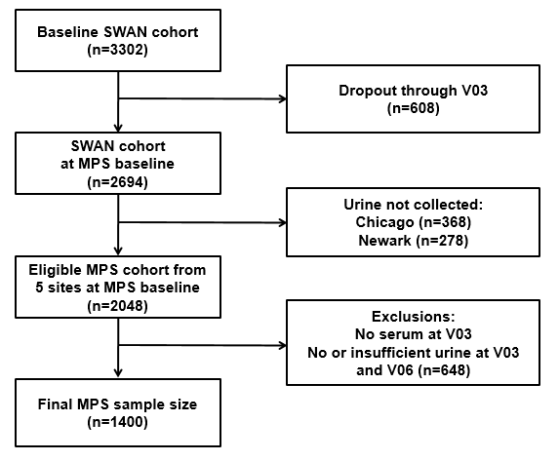

**Figure S1** The study designs of the Study of Women’s Health Across the Nation (SWAN) Multi-Pollutant Study (MPS).

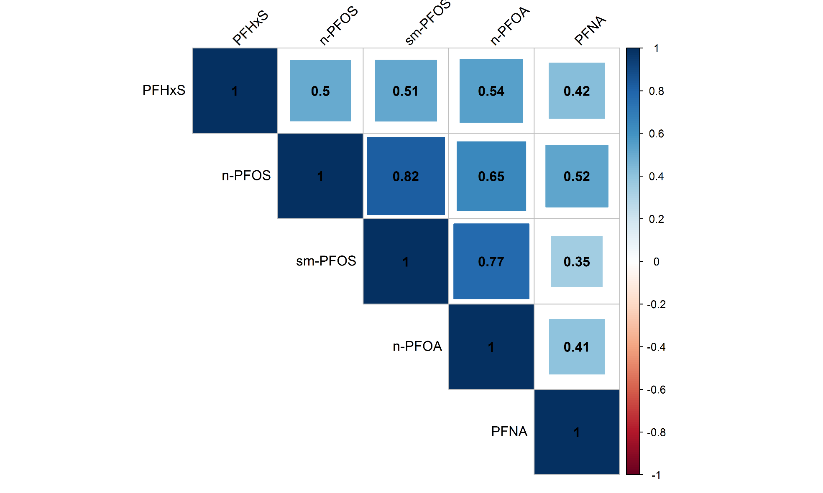

**Figure S2** Spearman correlation matrix of PFAS biomarkers in SWAN 1999-2000.

**Figure S3** Adjusted survival curves of natural menopause by tertiles of n-PFOS serum concentrations. The model was adjusted for age at baseline, race/ethnicity, study site, education, parity, BMI at baseline, physical activity, smoking status, and prior hormone use at baseline. The hazards ratio of tertile 2 and tertile 3 was 1.06 (0.86-1.31) and 1.26 (1.02-1.57), compared to tertile 1 (*ptrend*=0.03). The predicted median age at natural menopause was for tertile 1 was 52.6 years, and 52.3 years, and 51.6 years for tertiles 2 and 3, respectively.

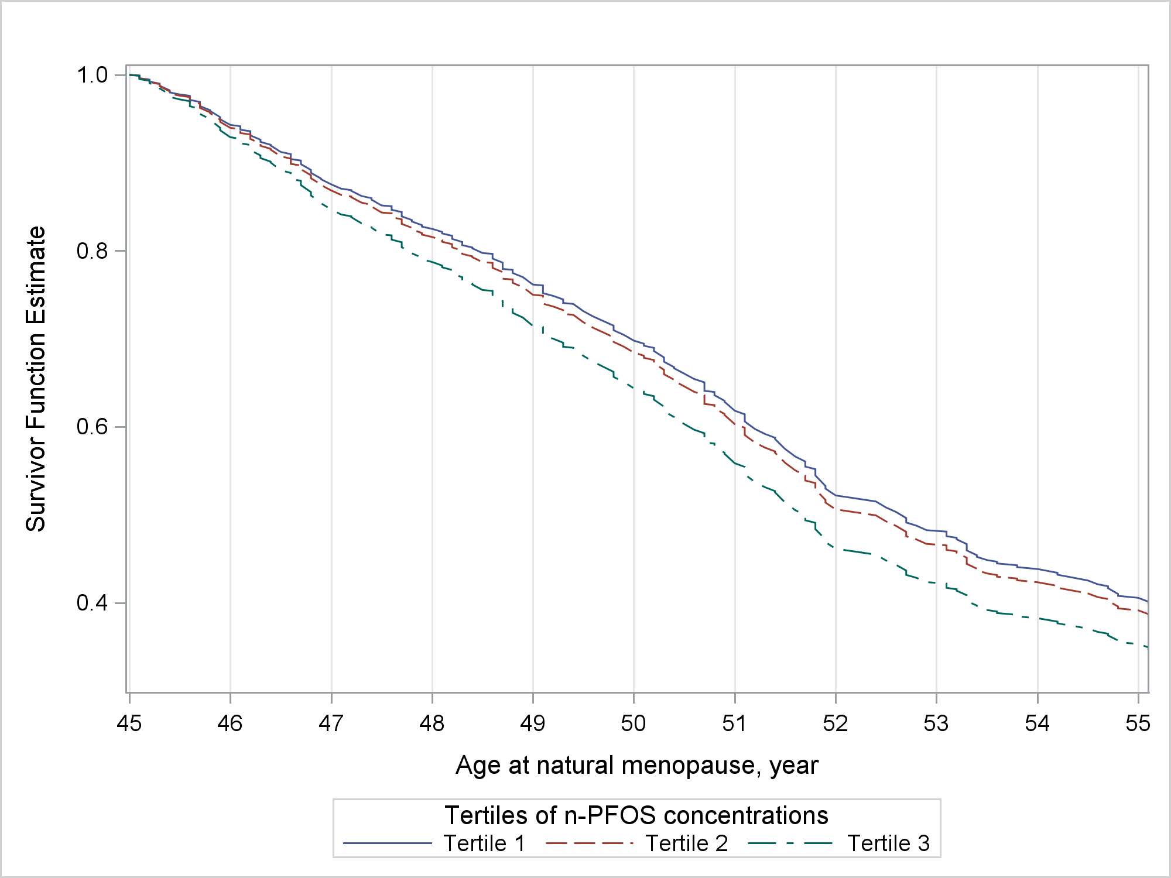

**Figure S4** Adjusted survival curves of natural menopause by tertiles of Sm-PFOS serum concentrations. The model was adjusted for age at baseline, race/ethnicity, study site, education, parity, BMI at baseline, physical activity, smoking status, and prior hormone use at baseline. The hazards ratio of tertile 2 and tertile 3 was 1.11 (0.90-1.37) and 1.27 (1.01-1.59), compared to tertile 1 (*ptrend*=0.03). The predicted median age at natural menopause for tertile 1 was 52.6 years, and 51.9 years, and 51.7 years for tertiles 2 and 3, respectively.

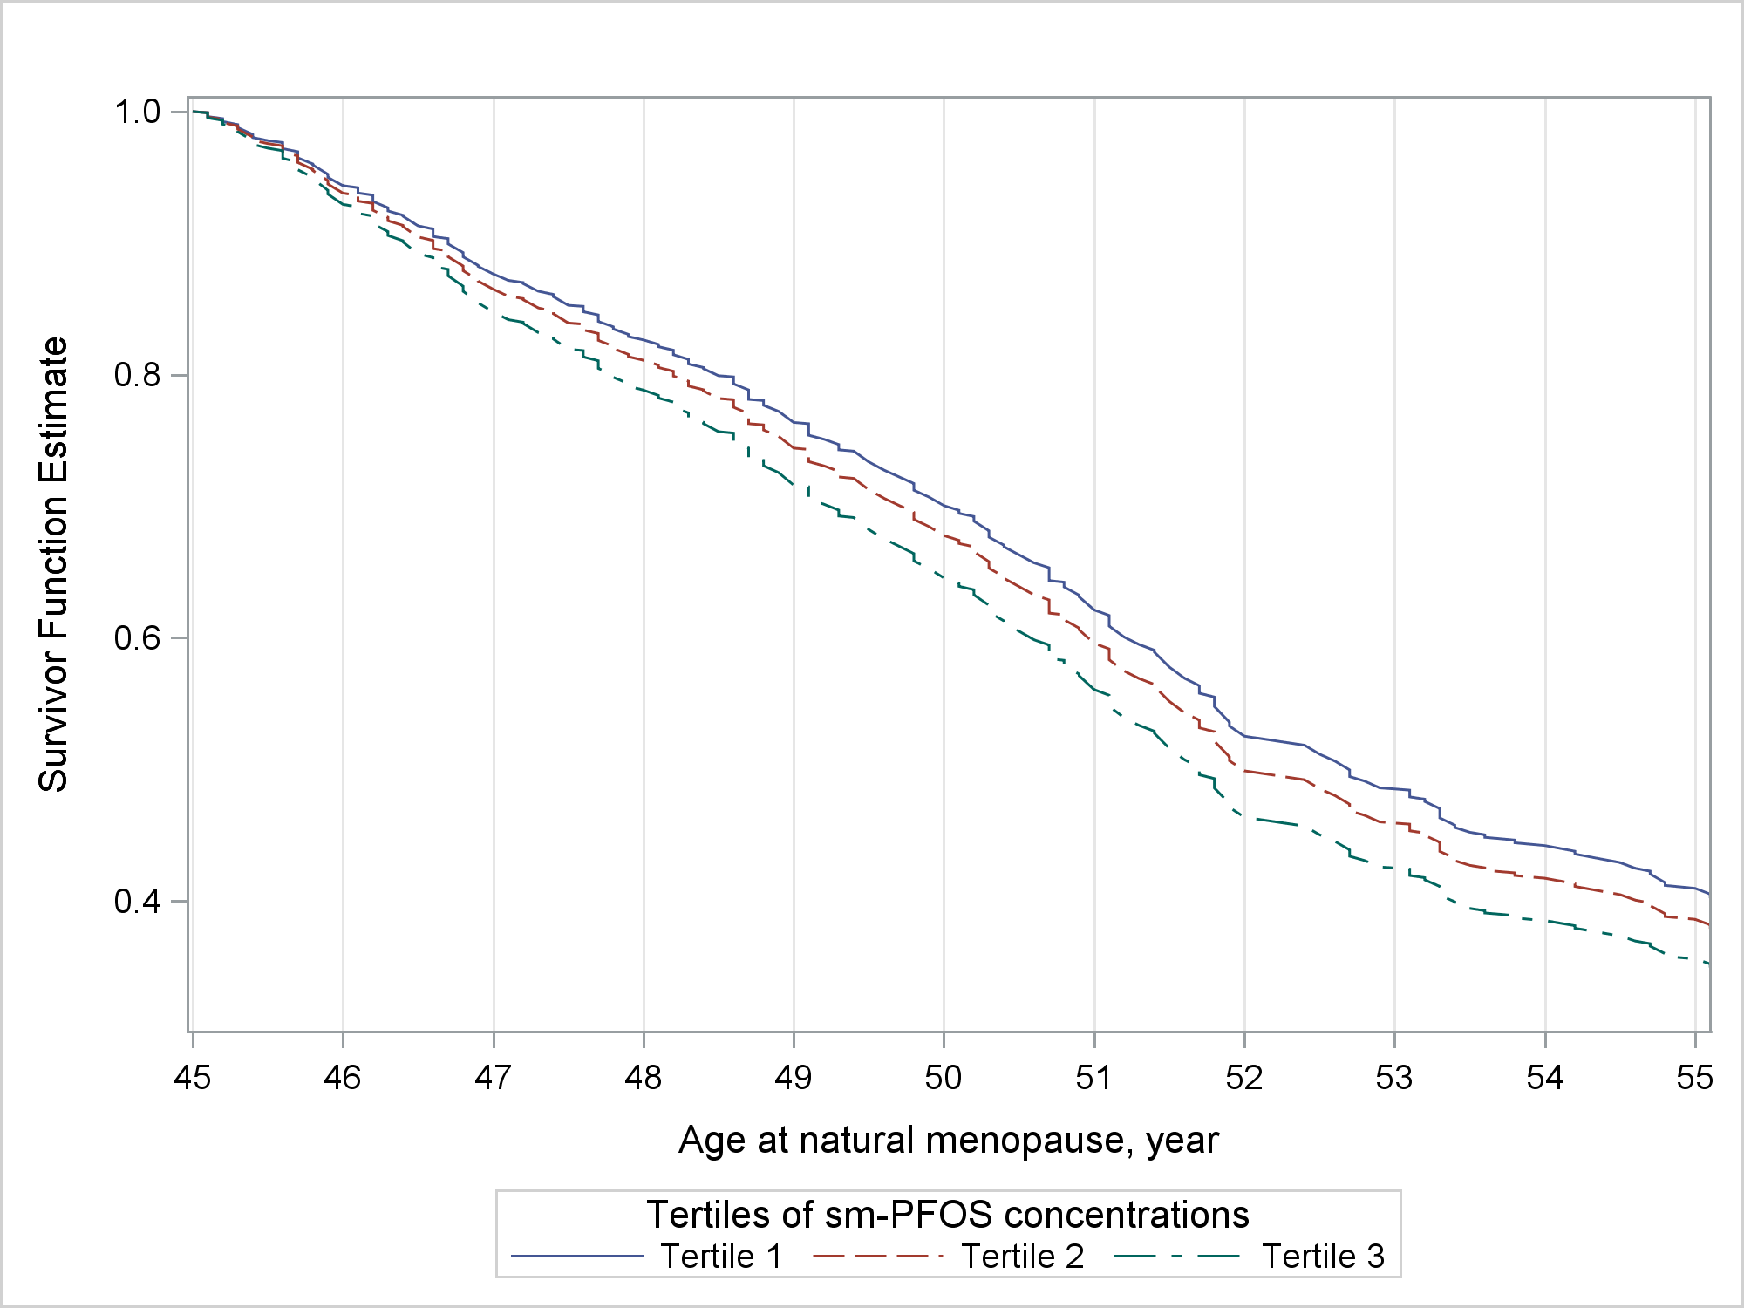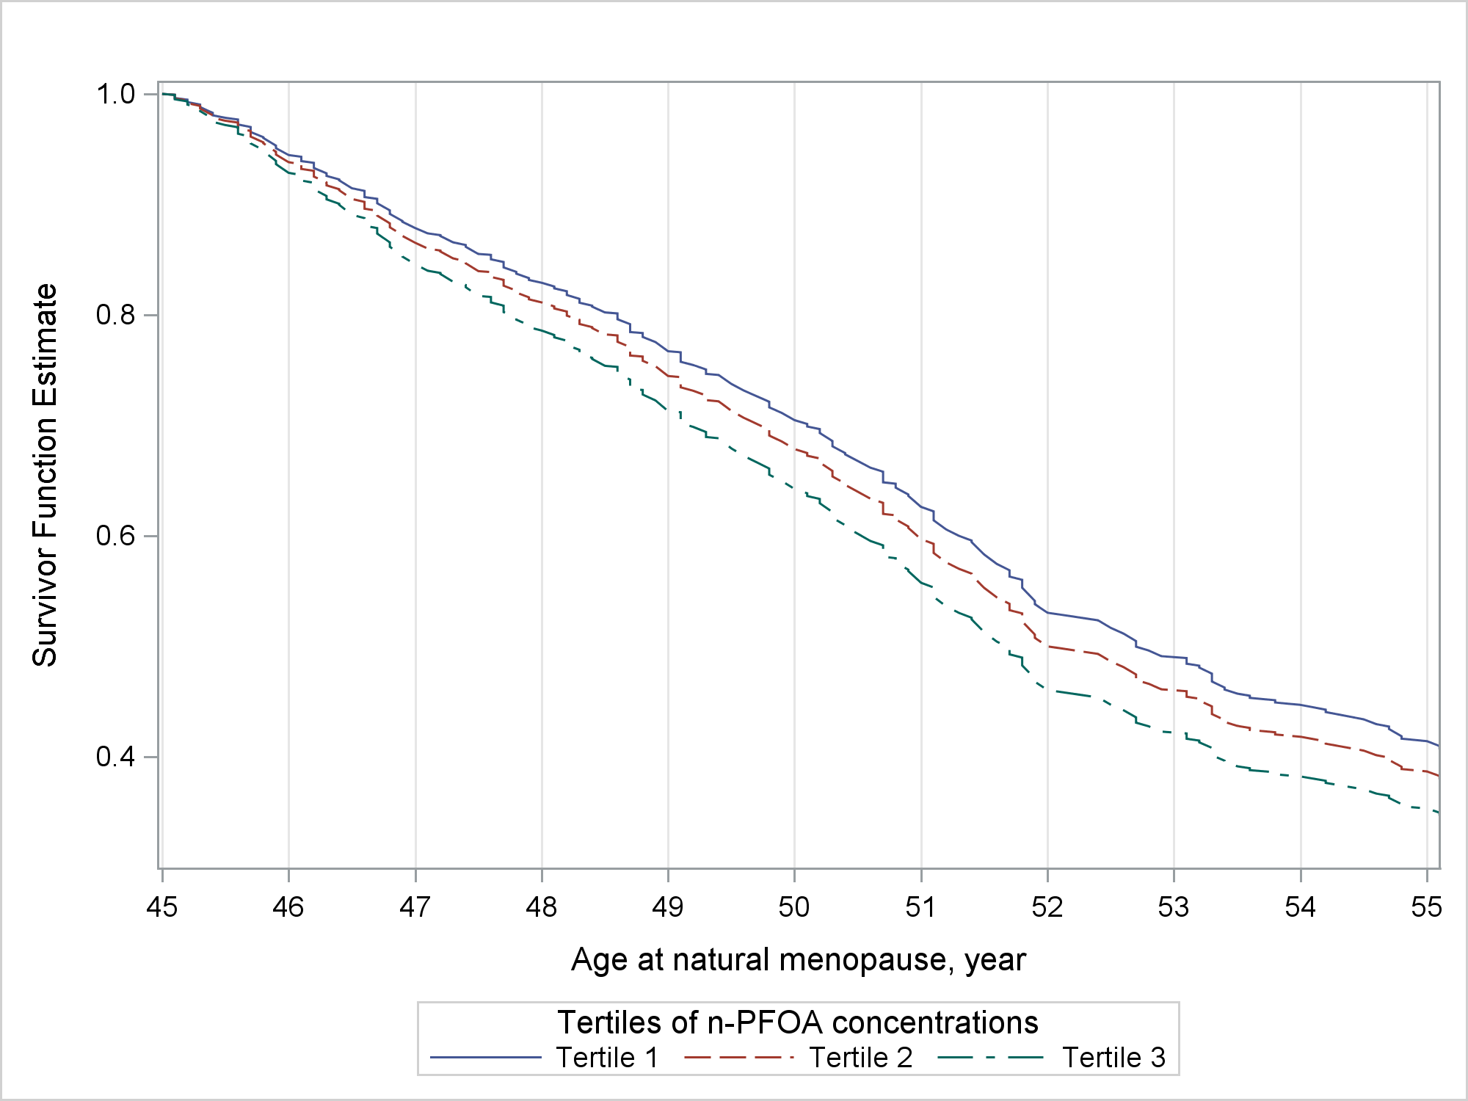

**Figure S5** Adjusted survival curves of natural menopause by tertiles of n-PFOA serum concentrations. The model was adjusted for age at baseline, race/ethnicity, study site, education, parity, BMI at baseline, physical activity, smoking status, and prior hormone use at baseline. The hazards ratio of tertile 2 and tertile 3 was 1.12 (0.90-1.40) and 1.31 (1.04-1.65), compared to tertile 1 (*ptrend*=0.01). The predicted median age at natural menopause for tertile 1 was 52.7 years, and 51.9 years, and 51.6 years for tertiles 2 and 3, respectively.

**Figure S6** Adjusted survival curves of natural menopause by tertiles of PFNA serum concentrations. The model was adjusted for age at baseline, race/ethnicity, study site, education, parity, BMI at baseline, physical activity, smoking status, and prior hormone use at baseline. The hazards ratio of tertile 2 and tertile 3 was 1.18 (0.95-1.47) and 1.20 (0.97-1.49), compared to tertile 1 (*ptrend*=0.10). The predicted median age at natural menopause for tertile 1 was 52.7 years, and 51.8 years, and 51.8 years for tertiles 2 and 3, respectively.

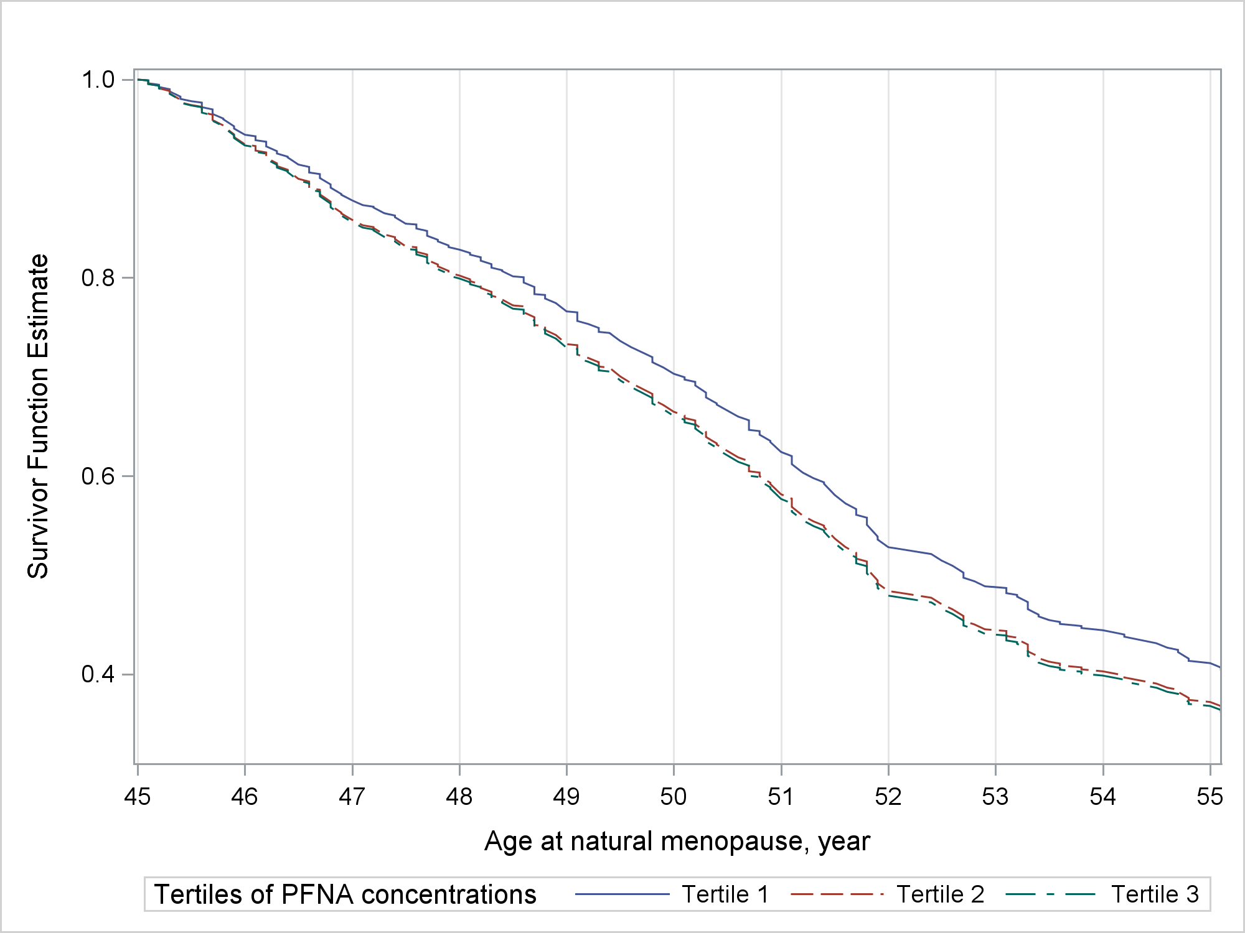

**Figure S7** Adjusted survival curves of natural menopause by tertiles of PFHxS serum concentrations. The model was adjusted for age at baseline, race/ethnicity, study site, education, parity, BMI at baseline, physical activity, smoking status, and prior hormone use at baseline. The hazards ratio of tertile 2 and tertile 3 was 1.05 (0.84-1.30) and 1.11 (0.90-1.37), compared to tertile 1 (*ptrend*=0.33). The predicted median age at natural menopause for tertile 1 was 52.4 years, and 51.9 years, and 51.8 years for tertiles 2 and 3, respectively.

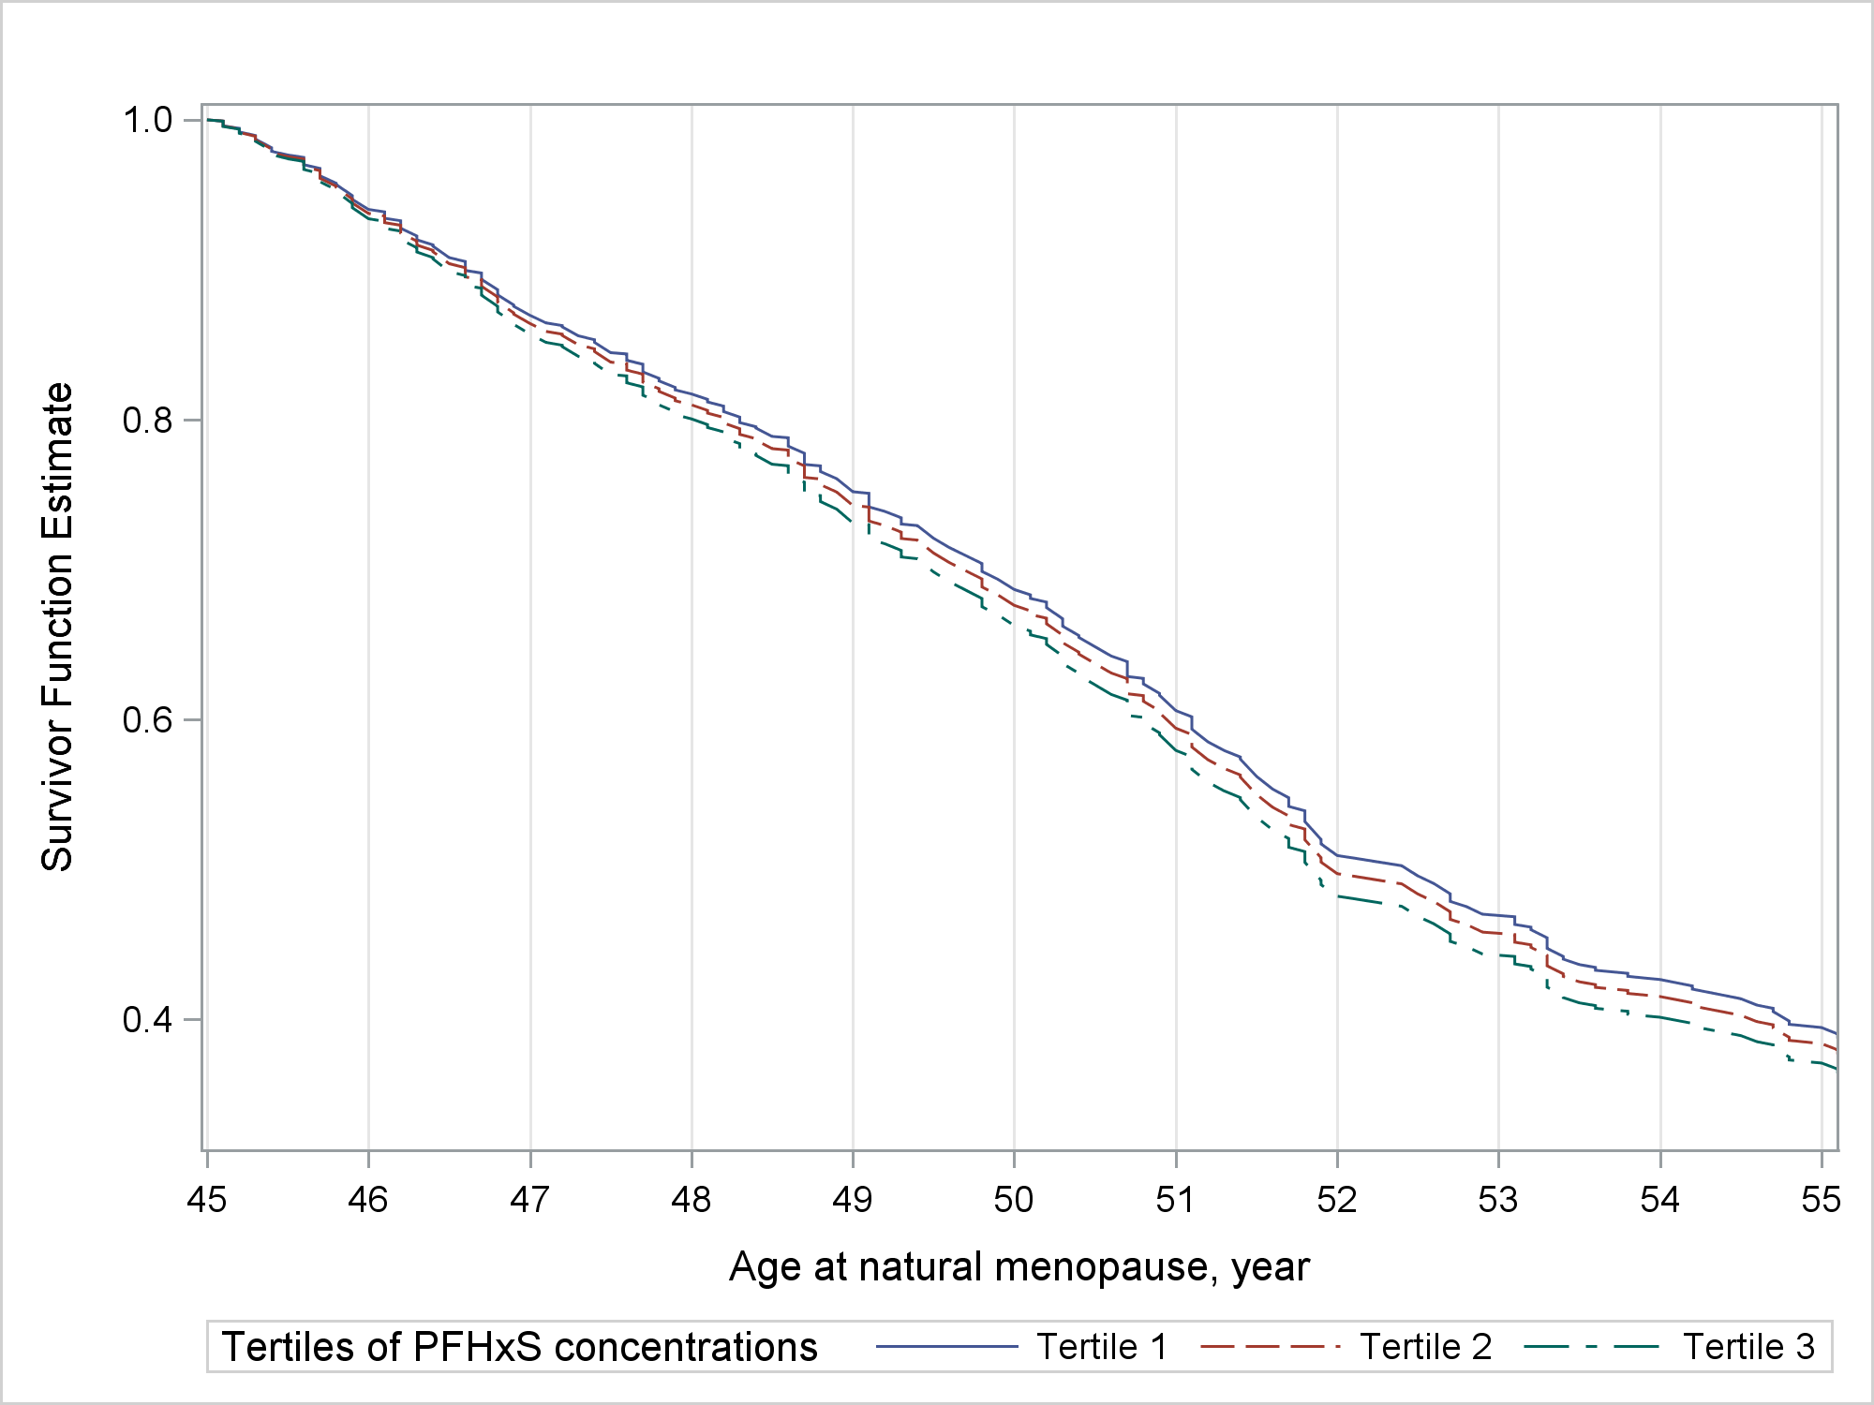

1. Exposure to **n-PFOS** and incidence of natural menopause by racial groups



1. Exposure to **Sm-PFOS** and incidence of natural menopause by racial groups



1. Exposure to **PFHxS** and incidence of natural menopause by racial groups



**Figure S8** Adjusted hazard ratio (HR) (95% confidence interval, 95% CI) of natural menopause incidence with per doubling increase in serum concentrations of n-PFOS, Sm-PFOS and PFHxS. Models were adjusted for age at baseline, study site, education, parity, BMI at baseline, physical activity, smoking status, and prior hormone use at baseline. *P* values for the interaction terms with race/ethnicity are 0.54 for n-PFOS, 0.52 for Sm-PFOS, and 0.03 for PFHxS.

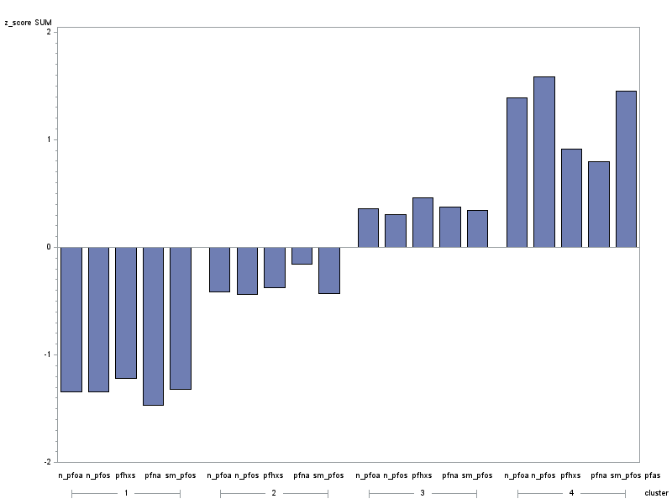

**Figure S9** Cluster means of the 5 standardized log-transformed serum PFAS concentrations using k-means clustering. Y-axis (cluster means) represents the mean standardized z-scores of log2-transformed PFAS concentrations. Cluster 1 (n=143): “low” overall PFAS concentration pattern; clusters 2 (n=414): “moderate low” overall PFAS concentration pattern; cluster 3 (n=406): “moderate high” overall PFAS concentration pattern; cluster 4 (n=157): “high” overall PFAS concentration pattern.